Shopee

Use-Case Specification: Search for Products and Sellers

Version 0.1

Revision History

| **Date** | **Version** | **Description** | **Author** |
| --- | --- | --- | --- |
| 16th Dec, 2023 | 0.1 | Final version | Nguyen Thi Hien Anh |
|  |  |  |  |
|  |  |  |  |
|  |  |  |  |

Table of Contents

1. Search for Products and Sellers 4

1.1 Brief Description 4

2. Flow of Events 4

2.1 Basic Flow 4

2.2 Alternative Flows 5

3. Special Requirements 5

4. Preconditions 5

5. Postconditions 5

6. Extension Points 5

7. Prototype

Use-Case Specification: Search for Products and Sellers

# Search for Products and Sellers

## Brief Description

Thís is the specification for Use case: Search Products and Sellers at the RD step, including the prototype for the interface. This use case describes the process of allowing guests and customers to search for products and sellers, returning and displaying the results to them.

# Flow of Events

## Basic Flow

The search bar is displayed at the top of the screen, the search view including the search bar, the search history list and search suggestion will appear when the user touches the bar.

When the user touches the search bar, if there is previous search, searching history will show up as a list below the bar, there is a search icon at the right corner of the search bar, the searching history list is loaded from the searching history database and will automatically display 4 most recent searches if there are, if the user chooses “Display more” this list will display a maximum 11 searches if there are 11 previous searches or more, the searches will always be displayed from most recent to further searches.

Also there will be a suggestion section below the list, including suggestions based on search or browse history, or basically based on the trend or data of the users. Generally, the search suggestion will be loaded from the database which is resulted from the user identification algorithm. The search suggestion would show up with 10 search suggestions, each suggestion displayed in a rectangle with an image of the search suggested and the searching keyword.

Users can choose available words to search from the searching history list, search suggestion list or type themselves.

When the user types on the search bar, the list of keywords suggested will appear below the search bar and the list will update every time the user enters a new keyword or changes the keywords.

After typing in the search bar and touching the search icon, or choosing available searching keywords in the search history section or the search suggestion section, the system will process to get the results and direct the user to the results screen.

Display the results:

The results screen includes the list of products or sellers that match the user's search in list form. Each seller is displayed in a vertical frame on the screen, each product is displayed in a rectangular frame, for the mobile app, 4 products can be displayed on 1 screen in 2 horizontal rows of 2 products.

For results for sellers: The horizontal bar along the frame, on the left, prominently displays the seller's name with the smaller sized seller's username below. Below the username, there will be the number of products and number of followers of the seller.

As for results for products: Each product is displayed in a frame that includes a large image of the product, the product name is below the image, and the product's price is prominently printed including the original price and the price after promotion if there is.

When clicking on a seller, the user will be directed to the seller’s page. When clicking on a product, the user will be directed to the product view to see more detailed information about the product, mark favorite the product, add the product to the cart. or buy the product.

## Alternative Flows

NA.

# Special Requirements

The representation image of the product should be scaled square and all the same size so that all the product have the same portion of frame.

# Preconditions

NA.

# Postconditions

The results are displayed successfully, users can browse the results and click on the results to see more detailed information.

The input of the user will be saved and displayed on the search history.

# Extension Points

NA.

# Prototype

Search bar

# 

Search View Keywords suggestions

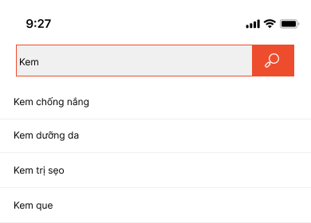

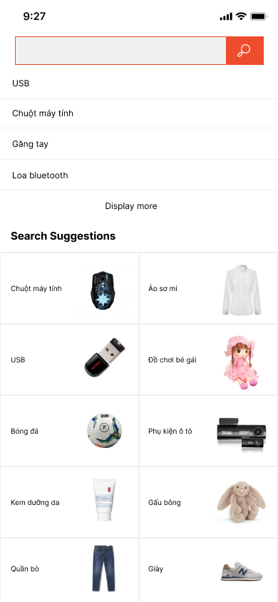

Display results